Curriculum Vitae
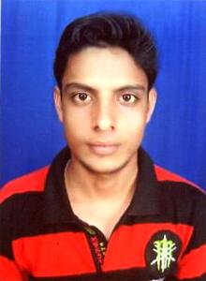

Mitrajit Panda

Mob : +91-9556230138
: +91-7205191472
E-mail : mitrajitpanda002@gmail.com

OBJECTIVE

To be associated with a progressive organization which can provide me with a dynamic work sphere to extract my inherent skills as a Professional, use and develop my aptitude to further the organization’s objectives and also attain my career targets in the progress.

ACADEMIC QUALIFICATIONS

Sl. No. | QUALIFICATION | SCHOOL/COLLEGE | BOARD / UNIVERSITY | YEAR OF PASSING | DIVISION | IN (%)
1 | B. Sc | Adikavi Saraladas College, Tirtol | Utkal University, Odisha | May 2013 | 2nd | 52.14
2 | +2 Science | Adikavi Saraladas College, Tirtol | C.H.S.E, Odisha | March, 2010 | 2nd | 53.17
3 | 10th | Sri Batamahapurusa Vidyapitha, Tartol | B.S.E, Odissa | March, 2008 | 2nd | 53.13

TRAININGS / PROJECTS UNDERTAKEN

- IT Basic(Computer fundamental, MS Office, Typing Skill(33wpm), Soft Skill.

- Successfully completed Tech Smart Courses at “Tech Smart Centre, Jeebika IT School, Tech Mahindra, Bhubaneswar.”

PROFFESSIONAL EXPERIENCE

Work Experience – 1yesr and6 Month*
Sector – Business Service Group (BSG)*
Company – Tech Mahindra*
Designation – Process Associate*

I have 13 month of work experience as on 2nd june 2016. I am working as a Process Associate at Tech Mahindra from 2nd June 2015.

PERSONAL DETAIL

Name : Mitrajit Panda
Father’s Name : Mr. Karunakar Panda
Mother’s Name : Mrs. Manjulata Panda
Age : 23 years.
DOB : 13th May 1993
Sex : Male
Marital Status : Single
Nationality : Indian
Permanent Address : At – Adhapati, Po - Dhanua
PS – Tirtol, Dist - Jagatsinghpur
State - Odisha, Pin - 754137
Mob No. : +91 - 9556230138, +91 - 7205191472
Languages Known : English, Hindi & Odia.

DECLARATION

I hereby declare that the above furnished information’s are authentic and true to best of my knowledge.

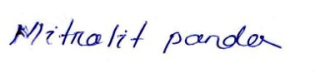

Date: 05/10/2016 (Signature)

Place: BHUBANESWAR Mitrajit Panda

